Exercise 1: SETTING UP **JUNIT**

Steps for setup:

**1. Create a new Java project in your IDE (e.g., VS-Code, IntelliJ IDEA, Eclipse).**

**2. Add JUnit dependency to your project. If you are using Maven, add the following to your pom.xml :**

<dependency>

<groupId>junit</groupId>

<artifactId>junit</artifactId>

<version>4.13.2</version>

<scope>test</scope>

</dependency>

**3. Create a new test class in your project.**

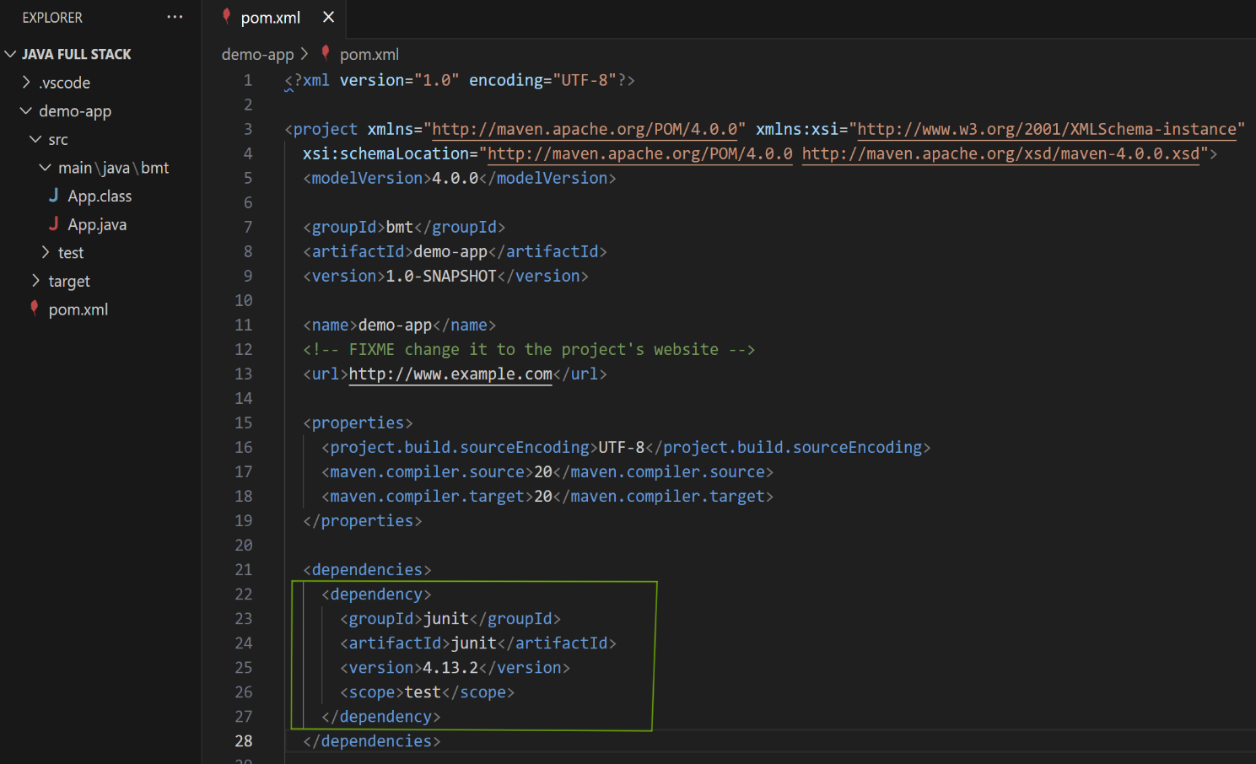 Solution to step 2: Adding JUnit dependency to **pom.xml :**

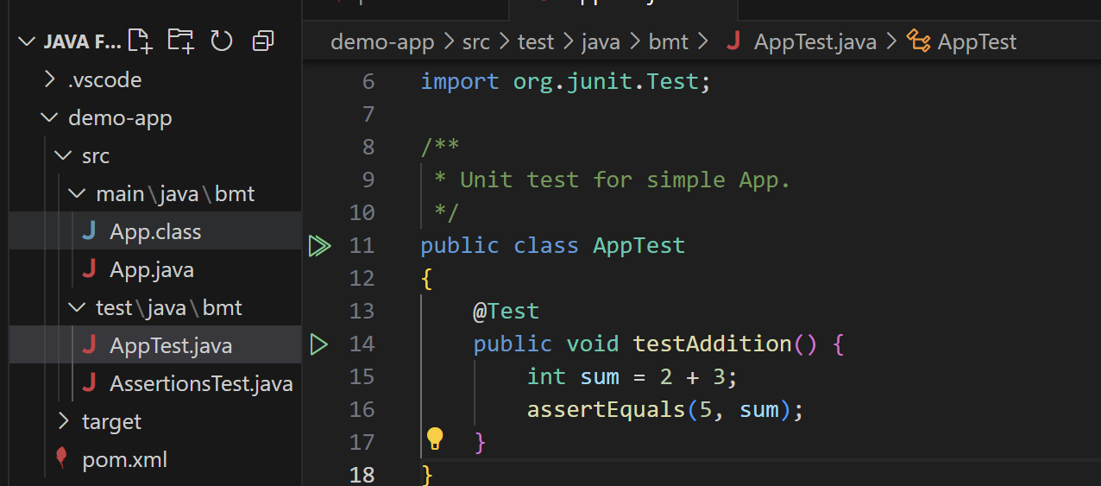Solution to step 3 : Creating a test class namely **AppTest.java :**

**Solution to step 1 :**

**I have used VS Code IDE for setting up a Java-Project for Junit setup.**

* **Let’s make some test-files in the next exercise.**

**\*\*\*\*\*\*\*\*\*\*\*\*\*\*\*\*\*\*\*\*\*\*\*\*\*\*\*\*\*\*\*\*\*\*\*\*\*\*\*\*\*\*\*\*\*\*\*\*\*\*\*\*\*\*\*\*\*\*\*\*\*\*\*\*\*\*\*\*\*\*\*\*\*\*\*\*\*\*\*\*\*\*\*\*\*\*\***